

**SOUL**

**Stories Online, Unified Library**

|  |  |  |
| --- | --- | --- |
| **Supervior:** | *LÊ THANH NHÂN* | |
| **Semester:** | *02* | |
| **Batch No:** | *T2.2410.E0* | |
| **Group No:** | *02* | |
| **Order:** | **Full name** | **Roll No.** |
| *1.* | *Tran Phuc Khang* | *Student1614879* |
| *2.* | *Mai Thanh Dat* | *Student1614903* |
| *3.* | *Nguyen Kim Minh* | *Student1614880* |

***Month****: 08* ***Year****: 2025*



This is to certify that

|  |  |
| --- | --- |
| **Mr.** | **Tran Phuc Khang** |
| **Mr.** | **Mai Thanh Dat** |
| **Mr.** | **Nguyen Kim Minh** |
|  |  |

Have successfully Designed & Developed

|  |  |  |
| --- | --- | --- |
|  |  |  |
| **SOUL**  **Stories Online, Unified Library** | | |

Submitted by:

|  |
| --- |
| **Mr. LE THANH NHAN** |

Date Of Issue:

|  |  |
| --- | --- |
|  |  |

Authorized Signature:

|  |  |
| --- | --- |
|  |  |
| **Content** | | | |

Content

Acknowledge

Synopsis

Review1

Review2

Review3

Testting Document

Final Checklist

Tasksheet

|  |
| --- |
| **Acknowledge** |

I would like to express my gratitude and appreciation to all those that my achievement currently by directly or indirectly during 1 – month to complete this project. A special thanks to my colleages who supports, idea suggestion and encouragement as well as promote me to coordinate my project especially in writing this report to accomplish the “SOUL” web designing.

I would like to acknowledge with much appreciation the critical role of FPT APTECH‘s staffs, who create the innovated and technical environment to all the student of the center have opportunities in applying the knowledge in practice, the work team skill and so forth. Plus, a special thanks to our parents for their endless love, care and have most assistances and motivation us for the whole of our life.

As last but not least, a great deal of thanks to the supervisor of the project, Mr. Le Thanh Nhan, who is full of energy, effort in guiding class in achieving the goal in the report such as web designing languages, methods, give standard formats in website designing sector as well as encouragement to maintain progress in track. Hence, I give my appreciation to other supervisor who indicate comment and tips in understanding the lectures, presentation formats that has improved our presentation skill.

Yours Sincerely,

Team Group 02.

|  |
| --- |
| **Synopsis** |

The objective of this project is to provide students with a real-life scenario where they can practice building applications using PHP/Laravel and MySQL. The main purpose is not to re-teach the concepts of PHP or Laravel, but rather to help us apply the knowledge we have already learned into developing a practical system. By doing so, we are able to revise the chapters we have studied earlier and strengthen our understanding through hands-on experience.

This project, named “SOUL”, is designed as a sample application that demonstrates how technology can bring together a wide range of knowledge and information. “SOUL” aims to provide access to content such as historic monuments, general knowledge, and even modern technology skills. It acts as a simple yet powerful tool to show how information from different domains can be gathered and presented in a structured way. Working on “SOUL” will also allow us to understand how small projects can eventually scale into larger, more robust applications.

The assignments related to this project are expected to be carried out during lab sessions, where faculty assistance will be available if required. This approach ensures that students are guided in the right direction while still encouraging independent problem solving. Finally, students are expected to carefully follow the project requirements, complete all tasks on time, and submit their work to ***[eprojects@aptech.ac.in](mailto:eprojects@aptech.ac.in)*** according to the schedule provided.

**Review 01**

|  |
| --- |
| **Problem Definition** |

Beginning with the development of Information Technology (IT), more and more people can easily use the Internet to serve their needs in daily life. Especially at present, mobile devices and the Internet have quickly become an essential part of almost everyone’s lives. Thus, introducing and advertising new products has become necessary for most companies in the market.

The SOUL company stores a wide collection of books and podcasts. They want to sell their products by launching a website where people can easily find all the information about the various items available. Customers can access the website through browsers such as Chrome, Internet Explorer, Firefox, etc., to explore and purchase books or podcasts offered by the company.

On our website, customers can find books and podcasts from well-known authors, publishers, and creators. Our collection includes a variety of genres, engaging content, and competitive pricing compared with other providers in the market. If customers wish to become members of SOUL, they can easily register for an account. Becoming a SOUL member comes with several benefits.

|  |
| --- |
| **Customer Requirements Specifications** |

1. **CRS/Requirements Specifications**

|  |  |
| --- | --- |
| Client/Project Undertaken: | |
| 1. | List of inputs to the system |
| a. | Registration/Login information (username, password, email). |
| b. | Personal details for profile update. |
| c. | Search keywords for books/podcasts. |
| d. | User comments on podcasts/books. |
| e. | Selection of books for borrow/return or bookmarking. |
| 2. | List of outputs expected from the system |
| a. | Login success/failure messages. |
| b. | User profile saved and displayed. |
| c. | Search results of books/podcasts based on keywords or filters. |
| d. | Access to book previews or podcast audio streaming. |
| e. | Notifications for borrow/return or bookmark actions. |
| 3. | Overview of processes involved in the system |
| a. | Users register/login to the system. |
| b. | Perform search and filtering of books/podcasts. |
| c. | View details, listen to podcasts, or preview books. |
| d. | Interact by commenting, bookmarking, or borrowing/returning books. |
| e. | Receive system responses (search results, confirmation messages, displayed content). |

|  |  |
| --- | --- |
| Admin/Project Undertaken: | |
| 1. | List of inputs to the system |
| a. | Admin login credentials. |
| b. | Data for adding/updating/deleting books and podcasts. |
| c. | Approval or rejection requests for podcasts. |
| d. | Requests to block/unblock users. |
| 2. | List of outputs expected from the system |
| a. | Successful access to the admin dashboard. |
| b. | List of users, books, and podcasts. |
| c. | Statistical reports (number of users, books, podcasts, activity logs). |
| d. | Confirmation messages for CRUD operations or approvals. |
| 3. | Overview of processes involved in the system |
| a. | Admin logs into the management dashboard. |
| b. | Manage users: view list, block/unblock accounts. |
| c. | Manage books: add, update, delete records. |
| d. | Manage podcasts: approve, edit, delete items. |
| e. | Generate and review statistical reports from the dashboard. |

|  |  |
| --- | --- |
| Hardware and software required for implementing the project | |
| a. | Personal computer/laptop (Core i5 or higher, 8GB RAM, 256GB SSD) |
| b. | Internet connection |
| c. | Operating System: Windows 10 or later |
| d. | Development Tools: VS Code |
| e. | Server: Laragon |
| f. | Database: MySQL |
| g. | Framework: Laravel |
| h. | Browser: Chrome / Edge |

1. **CRS/Customer Acceptance Criteria**

|  |  |
| --- | --- |
| **S.No** | **Customer's Acceptance Criteria** |
| 1 | **Given** a new user without an account, **when** they register with valid details, **then** the system creates the account successfully. |
| 2 | **Given** a registered user, **when** they enter valid credentials to log in, **then** the system grants access to their profile. |
| 3 | **Given** a registered user, **when** they enter invalid credentials, **then** the system shows an error message. |
| 4 | **Given** a logged-in user, **when** they update their profile, **then** the system saves and displays the updated information. |
| 5 | **Given** a logged-in user, **when** they search for a book by title or author, **then** the system displays relevant search results. |
| 6 | **Given** a logged-in user, **when** they click on a podcast, **then** the system plays the audio and shows details. |
| 7 | **Given** a logged-in user, **when** they bookmark a book, **then** the system saves it to their personal list. |
| 8 | **Given** a logged-in user, **when** they post a comment on a podcast, **then** the system displays it under the podcast details. |
| 9 | **Given** an admin user, **when** they block a customer account, **then** that customer cannot log in anymore. |
| 10 | **Given** an admin user, **when** they view the dashboard, **then** the system displays statistics of users, books, and podcasts. |

1. **Project Plan**

|  |  |  |
| --- | --- | --- |
| 1. Project Details | | |
| + | Name of the Client: SOUL | |
| + | Date of Project Plan: 20-08-2025 | |
| + | Project Vision/Objectives: | |
| a. | This project aims to build an integrated web system for managing users, books, and podcasts. | |
| b. | Support book searching, borrowing, returning, podcast streaming, and management through an admin dashboard. | |
| c. | Deliver a centralized platform that enhances access to learning and recreational resources. | |
| + | Scope: | |
| a. | Authentication & User Management | |
|  | + | Register/login |
|  | + | Profile management, password reset email. |
|  | + | Admin: list/block/unblock users (dashboard) |
| b. | Podcast | |
|  | + | Backend: CRUD API, upload/download audio. |
|  | + | Frontend: listing, filtering, pagination, detail page with comments |
|  | + | Admin: approve, edit, delete podcasts (dashboard) |
| c. | Books | |
|  | + | Backend: CRUD, borrow/return, bookmark. |
|  | + | Frontend: book listing, detail page, preview reading. |
|  | + | Admin: generate reports (users/books/podcasts) and activity logs. |
| + | Our understanding of the client organization: | |
| a. | The client requires a centralized platform to manage books and podcasts. | |
| b. | An admin dashboard is essential to monitor users, control content, and track system logs. | |
| + | Project Organization with Responsibilities and Authorities: | |
| a. | **Student Team:** Development, Testing, Documentation | |
| b. | **Faculty (Supervisor):** Guidance, Approval, Review | |
| c. | **Admin Role in System:** Manage users, books, and podcasts | |
| 2. Project Initiation/Requirement Documents | | |
| a. | Customer Requirements Specification | |
| b. | Software Design Document | |
| c. | Database Schema & API Contracts | |
| 3. Deliverables | | |
| a. | Complete source code (Laravel + NextJS + MySQL). | |
| b. | Project documentation including report, design, API guide, and user manual. | |
| 4. Project Dependencies | | |
| a. | Frameworks: Laravel (backend), NextJs (frontend) | |
| b. | Database: MySQL | |
| 5. Major Project Milestones | | |
| a. | **Week 1** – Requirement analysis and system design. | |
| b. | **Week 2** – Backend development (Authentication, Books & Podcasts APIs). | |
| c. | **Week 3** – Frontend development (UI + integration with backend). | |
| d. | **Week 4** – Testing, documentation, and final submission. | |
| 6. Quality Plan | | |
| + | Review Activities: | |
| a. | Weekly code reviews to ensure coding standards. | |
| b. | Documentation review before submission. | |
| c. | Regular progress review meetings. | |
| + | Testing Activities: | |
| a. | Unit testing for backend and frontend modules. | |
| b. | Integration testing between components. | |
| c. | User Acceptance Testing | |
| + | Backup and recovery strategies: | |
| a. | Daily backup of source code to GitHub repository. | |
| b. | Maintain a local backup copy on external storage. | |
| c. | Recovery plan: restore from latest stable backup in case of system failure. | |

**WBS Diagram for SOUL Web Application Project**

|  |
| --- |
|  |

**Review 02**

|  |
| --- |
| **Architecture and design of the Application** |

1. **Application Architecture**
2. Layers (Layered Architecture)
   1. Presentation Layer (Frontend – Next.js/React)

* Provides UI for users, staff, and admin
* Calls backend APIs (via axios/fetch)
* Manages authentication token/session
* Main pages:
* Register/Login, Profile management
* Podcast list/detail
* Books grid/detail with bookmark, preview
* Admin Dashboard
  1. Application Layer (Backend - Laravel API)
* Handles business logic (Controllers + Services)
* Authentication & Authorization
* CRUD operations: User, Podcast, Book, Logs
* Business rules: borrow/return books, approve podcasts, block/unblock users
* Provides RESTful API for frontend
  1. Data Layer
* Stores users, books, podcasts, logs, bookmark records
* Supports full-text search (for Books/Podcasts)
* Relational database schema with foreign keys

1. Roles

**User:** Register, login, edit profile, view books, view podcasts, bookmark books

**Admin:** Full access – manage users, block/unblock accounts, view dashboard stats

1. Workflow Summary

* **User** logs in → JWT token stored in frontend
* **Frontend** sends API requests with token → **Backend** checks authentication/authorization (middleware)
* **Backend** processes request and interacts with **Database**
* **Admin** uses dashboard to monitor users, podcasts, and books
* **Users** search, bookmark, borrow/return books, listen to podcasts

1. **Data Flow Diagram**

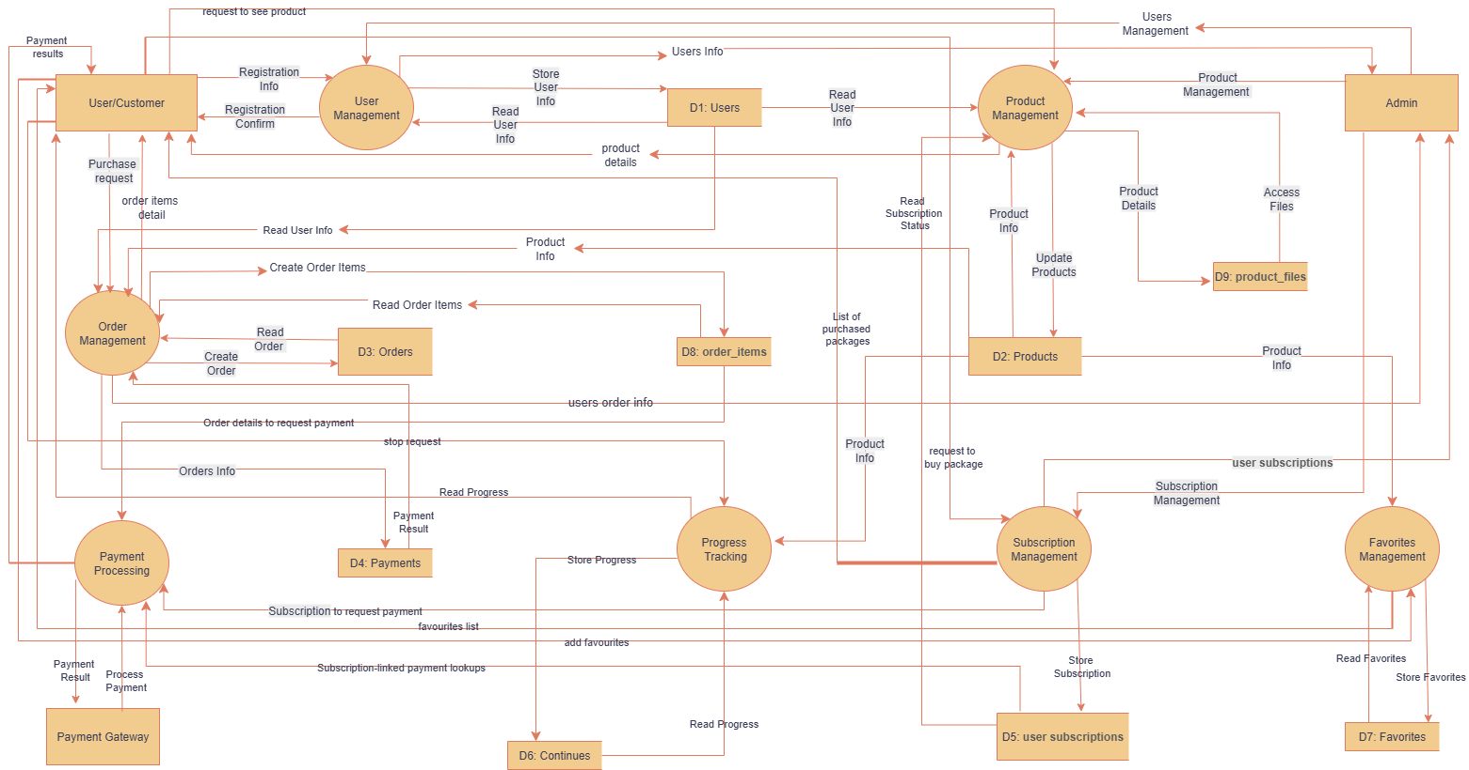

|  |
| --- |
| **Entity Relationship Diagram** |

1. **ERD**

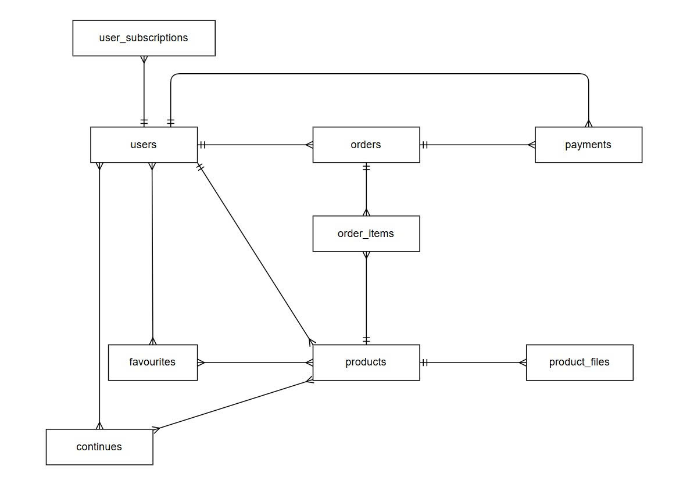

1. **ERD Properties**

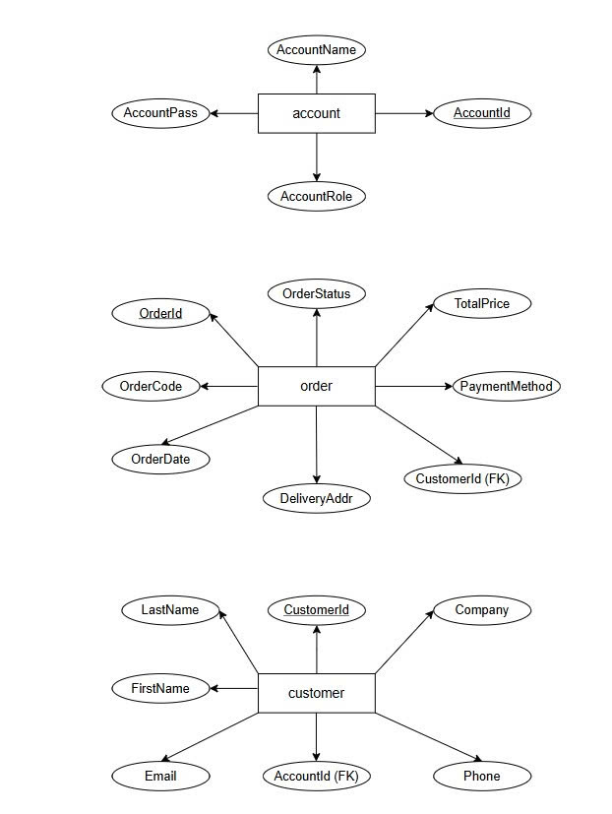

|  |
| --- |
| **Table Design** |

1. **Table Design**

|  |  |  |  |  |  |
| --- | --- | --- | --- | --- | --- |
| **USER** | | | | | |
| **Serial** | **Field** | **Data Type** | **Keys** | **Constraints** | **Description** |
| 1 | Id | INT | PK | AUTO_INCREMENT, NOT NULL | User ID |
| 2 | Email | VARCHAR(50) |  | UNIQUE, NOT NULL | Email |
| 3 | Password | VARCHAR(255) |  | NOT NULL | PASSWORD |
| 4 | Role | VARCHAR(50) |  | DEFAULT ‘user’ | User role |
| 5 | Name | VARCHAR(100) |  | NOT NULL | FULL NAME |
| 6 | Time | TIMESTAMP |  |  | Activity time |
| 7 | Is_active | BOOLEAN |  | DEFAULT TRUE | Active Status |
| 8 | Created_at | TIMESTAMP |  | DEFAULT CURRENT_TIMESTAMP | Created time |
| 9 | Updated_at | TIMESTAMP |  | ON UPDATE CURRENT TIMESTAMP | Updated time |

|  |  |  |  |  |  |
| --- | --- | --- | --- | --- | --- |
| **USER_SUBSCRIPTION** | | | | | |
| **Serial** | **Field** | **Data Type** | **Keys** | **Constraints** | **Description** |
| 1 | Id | INT | PK | AUTO_INCREMENT, NOT NULL | Subscription ID |
| 2 | User_id | INT | FK | NOT NULL, REFERENCES users(id) | Linked user |
| 3 | Plan_key | VARCHAR(50) |  | NOT NULL | Subscription plan key |
| 4 | Price_cents | INT |  | NOT NULL | Price |
| 5 | Start_date | DATE |  | NOT NULL | Start date |
| 6 | End_date | DATE |  | NULL | Subscription Status |
| 7 | status | VARCHAR(20) |  | DEFAULT 'active' | Subscription status |
| 8 | payment_id | INT | FK | REFERENCES payments(id) | Linked payment |
| 9 | Created_at | TIMESTAMP |  | DEFAULT CURRENT_TIMESTAMP | Created time |
| 10 | Updated_at | TIMESTAMP |  | ON UPDATE CURRENT TIMESTAMP | Updated time |

|  |  |  |  |  |  |
| --- | --- | --- | --- | --- | --- |
| **FAVOURITES** | | | | | |
| **Serial** | **Field** | **Data Type** | **Keys** | **Constraints** | **Description** |
| 1 | Id | INT | PK | AUTO_INCREMENT, NOT NULL | Favourite ID |
| 2 | User_id | INT | FK | NOT NULL, REFERENCES users(id) | User reference |
| 3 | Product_id | INT | FK | NOT NULL, REFERENCES products(id) | Product reference |
| 4 | Created_at | TIMESTAMP |  | DEFAULT CURRENT_TIMESTAMP | Created time |

|  |  |  |  |  |  |
| --- | --- | --- | --- | --- | --- |
| **ORDERS** | | | | | |
| **Serial** | **Field** | **Data Type** | **Keys** | **Constraints** | **Description** |
| 1 | Id | INT | PK | AUTO_INCREMENT, NOT NULL | Order ID |
| 2 | User_id | INT | FK | NOT NULL, REFERENCES users(id) | Linked user |
| 3 | total_cents | INT |  | NOT NULL | Total order price |
| 4 | status | VARCHAR(20) |  | DEFAULT 'processing' | Order status |
| 5 | payment_method | VARCHAR(50) |  | NULL | Payment method |
| 6 | Created_at | TIMESTAMP |  | DEFAULT CURRENT_TIMESTAMP | Created time |
| 7 | Updated_at | TIMESTAMP |  | ON UPDATE CURRENT TIMESTAMP | Updated time |

|  |  |  |  |  |  |
| --- | --- | --- | --- | --- | --- |
| **ORDERS_ITEM** | | | | | |
| **Serial** | **Field** | **Data Type** | **Keys** | **Constraints** | **Description** |
| 1 | Id | INT | PK | AUTO_INCREMENT, NOT NULL | Order ID |
| 2 | Order_id | INT | FK | NOT NULL, REFERENCES orders(id) | Order reference |
| 3 | product_id | INT | FK | NOT NULL, REFERENCES products(id) | Product reference |
| 4 | unit_price_cents | INT |  | NOT NULL | Price per unit (cents) |
| 5 | quantity | INT |  | DEFAULT 1, NOT NULL | Quantity ordered |
| 6 | Created_at | TIMESTAMP |  | DEFAULT CURRENT_TIMESTAMP | Created time |

|  |  |  |  |  |  |
| --- | --- | --- | --- | --- | --- |
| **PAYMENTS** | | | | | |
| **Serial** | **Field** | **Data Type** | **Keys** | **Constraints** | **Description** |
| 1 | Id | INT | PK | AUTO_INCREMENT, NOT NULL | Subscription ID |
| 2 | User_id | INT | FK | NOT NULL, REFERENCES users(id) | Linked user |
| 3 | Order_id | INT | FK | NOT NULL, REFERENCES orders(id) | Order reference |
| 4 | Provider | VARCHAR(50) |  | NOT NULL | Payment Provider |
| 5 | amount_cents | INT |  | NOT NULL | Payment amount |
| 6 | currency | VARCHAR(10) |  | DEFAULT 'USD' | Currency code |
| 7 | status | VARCHAR(20) |  | DEFAULT 'pending' | Payment status |
| 8 | provider_payment_id | VARCHAR(100) |  | NULL | Provider transaction ID |
| 9 | raw_response | TEXT |  | NULL | Gateway response data |
| 10 | Created_at | TIMESTAMP |  | DEFAULT CURRENT_TIMESTAMP | Created time |

|  |  |  |  |  |  |
| --- | --- | --- | --- | --- | --- |
| **PRODUCTS** | | | | | |
| **Serial** | **Field** | **Data Type** | **Keys** | **Constraints** | **Description** |
| 1 | Id | INT | PK | AUTO_INCREMENT, NOT NULL | Subscription ID |
| 2 | Type | VARCHAR(50) |  | NOT NULL | Product type |
| 3 | Title | VARCHAR(150) |  | NOT NULL | Product title |
| 4 | Description | TEXT |  | NULL | Product description |
| 5 | price_cents | INT |  | NOT NULL | Price in cents |
| 6 | thumbnail_url | VARCHAR(255) |  | NULL | Thumbnail image URL |
| 7 | category | VARCHAR(50) |  | NULL | Product category |
| 8 | slug | VARCHAR(150) |  | UNIQUE | SEO slug |
| 9 | metadata | JSON |  | NULL | Metadata (extra info) |
| 10 | is_active | BOOLEAN |  | DEFAULT TRUE | Active status |
| 11 | Created_at | TIMESTAMP |  | DEFAULT CURRENT_TIMESTAMP | Created time |
| 12 | Updated_at | TIMESTAMP |  | ON UPDATE CURRENT TIMESTAMP | Updated time |

|  |  |  |  |  |  |
| --- | --- | --- | --- | --- | --- |
| **PRODUCTS_FILES** | | | | | |
| **Serial** | **Field** | **Data Type** | **Keys** | **Constraints** | **Description** |
| 1 | Id | INT | PK | AUTO_INCREMENT, NOT NULL | File ID |
| 2 | product_id | INT | FK | NOT NULL, REFERENCES products(id) | Linked product |
| 3 | file_type | VARCHAR(50) |  | NOT NULL | File type (pdf, mp3…) |
| 4 | file_url | VARCHAR(255) |  | NOT NULL | File storage URL |
| 5 | filesize_bytes | BIGINT |  | NULL | File size (bytes) |
| 6 | is_preview | BOOLEAN |  | DEFAULT FALSE | preview file |
| 7 | meta | JSON |  | NULL | Metadata |
| 8 | Created_at | TIMESTAMP |  | DEFAULT CURRENT_TIMESTAMP | Created time |
| 9 | Updated_at | TIMESTAMP |  | ON UPDATE CURRENT TIMESTAMP | Updated time |

|  |  |  |  |  |  |
| --- | --- | --- | --- | --- | --- |
| **CONTINUES** | | | | | |
| **Serial** | **Field** | **Data Type** | **Keys** | **Constraints** | **Description** |
| 1 | Id | INT | PK | AUTO_INCREMENT, NOT NULL | File ID |
| 2 | product_id | INT | FK | NOT NULL, REFERENCES products(id) | Linked product |
| 3 | User_id | INT | FK | NOT NULL, REFERENCES users(id) | Linked user |
| 4 | Current_chapter | INT |  | NULL | Current chapter |
| 5 | Current_page | INT |  | NULL | Current page |
| 6 | Current_time_seconds | INT |  | NULL | Playback time (seconds) |
| 7 | Updated_at | TIMESTAMP |  | ON UPDATE CURRENT TIMESTAMP | Updated time |

1. **Relationship Diagram**

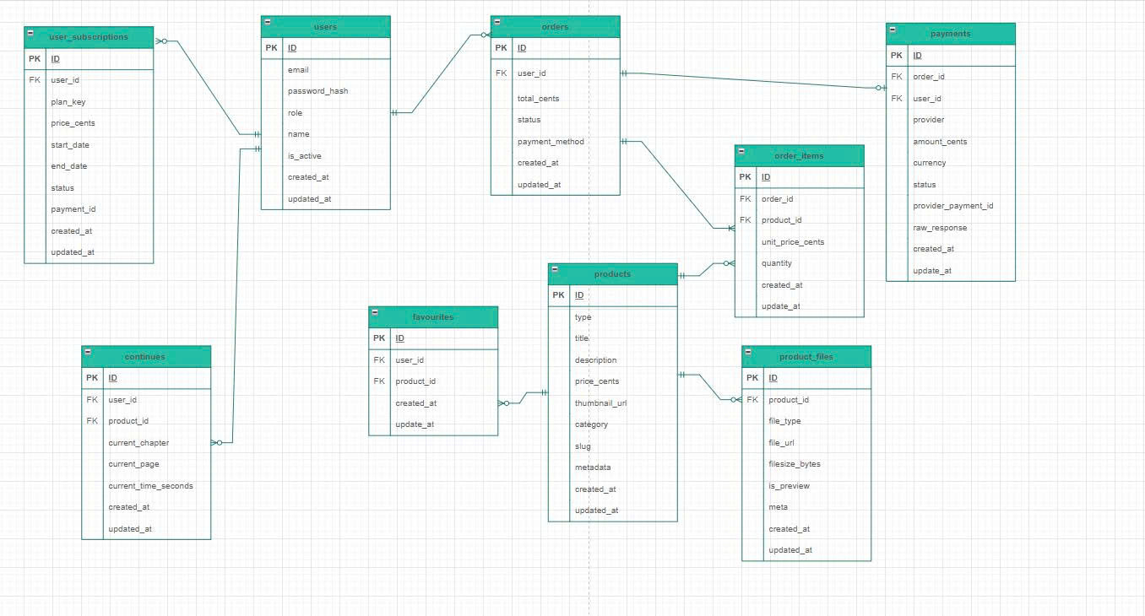

|  |
| --- |
| **Algorithm** |

1. **Administraror**

Step 1: Administrator logs into the system

Step 2: Check user role

IF role == "admin" THEN

Display full management features:

- Manage Users (CRUD: create, update, delete, assign roles)

- Manage Books (CRUD)

- Manage Categories (CRUD)

- Manage Podcasts (CRUD)

- Manage Staff

- View system reports/statistics

ELSE

Return "Access Denied"

END

|  |
| --- |
|  |

1. **User**

Step 1: User logs in or accesses the system

Step 2: Check user role

IF role == "user" THEN

Display basic features:

- View book list

- View book details

- Search books

- View categories

- Listen/download podcasts

- Manage personal profile

- Change password

ELSE

Return "Access Denied"

END

|  |
| --- |
|  |

**SITE MAP OF SOUL**

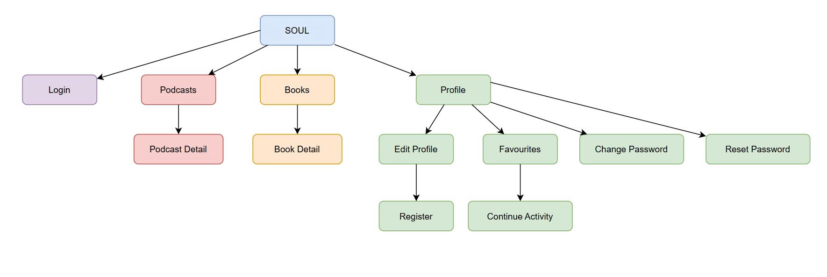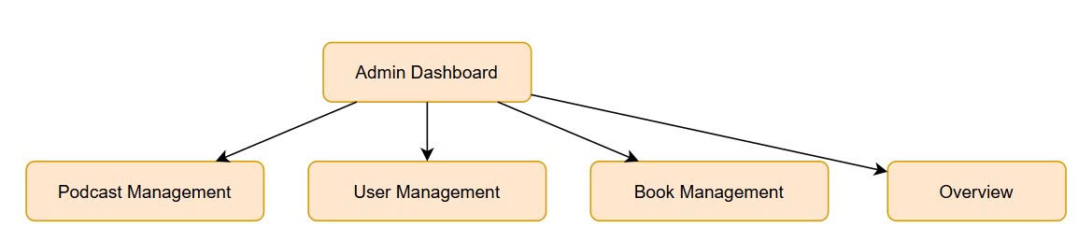

**Review 03**

|  |
| --- |
| **Screen shots** |

1. **Homepage:**

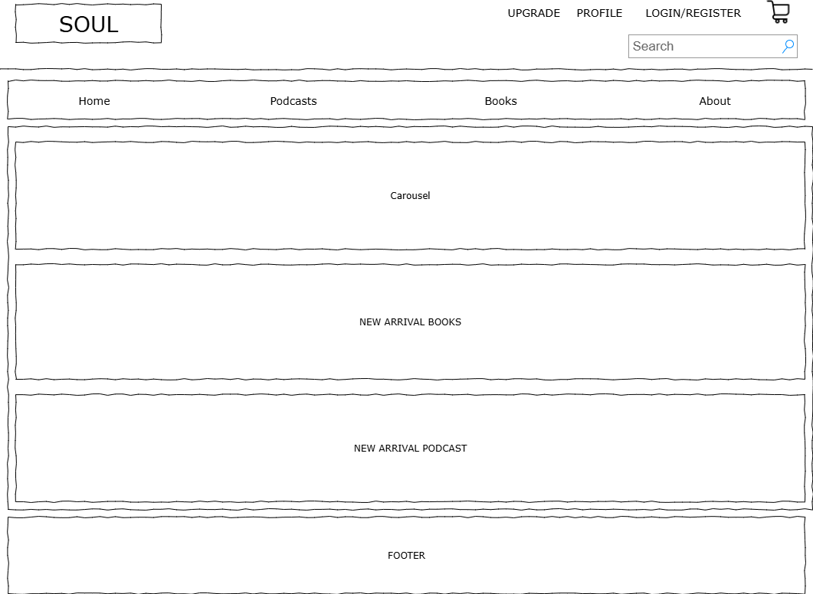

**Description**: The main entry point of the website, showing an overview of both **Books** and **Podcasts i**ncludes a **header** (main menu, podcasts, books, profile, search, order), a **sidebar** with categories/filters, and a **footer**.

**From**: Accessed from the **Home menu** (top navigation).

**To**: Navigate to Books Page, Podcasts Page, Profile Page, Login/Register, Order Page

1. **Login Form**

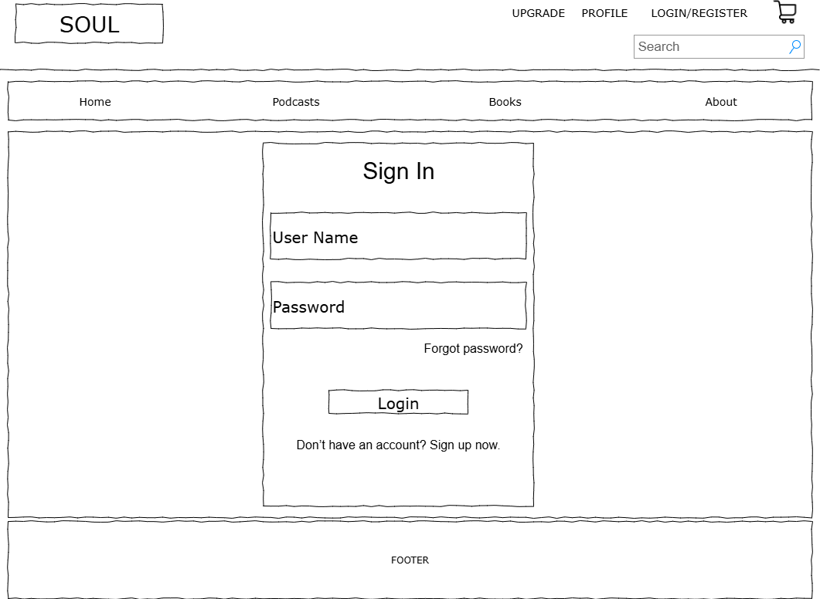

**Description:** Allows users to log in to store their information  
**From:** From the website header  
**To:** Can lead to any other page such as Home, Podcasts, Books, Upgrade, Profile, ...

1. **Register Form**

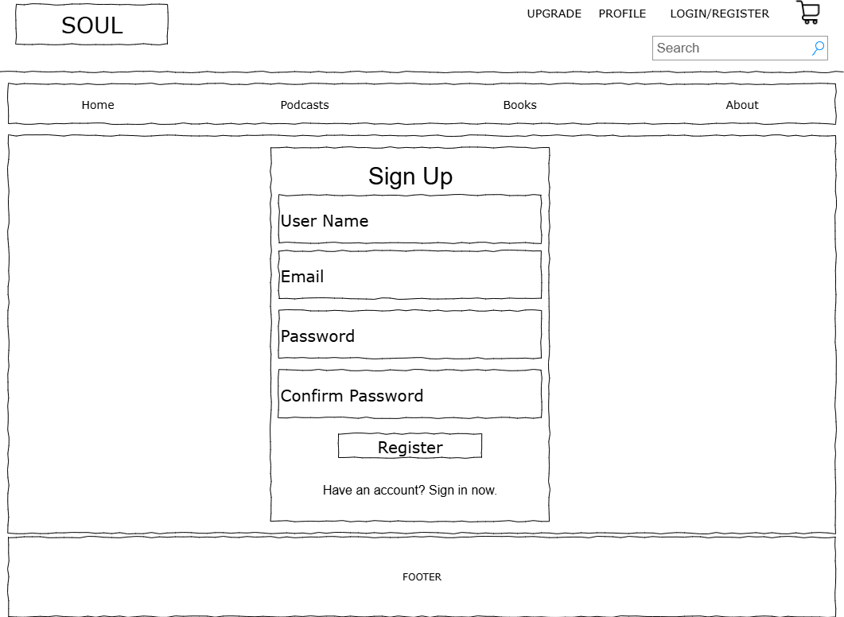

**Description:** Allows users to sign up and create an account  
**From:** From the website header  
**To:** Can lead to any other page such as Home, Podcasts, Books, Upgrade, Profile, …

1. **Books Page**

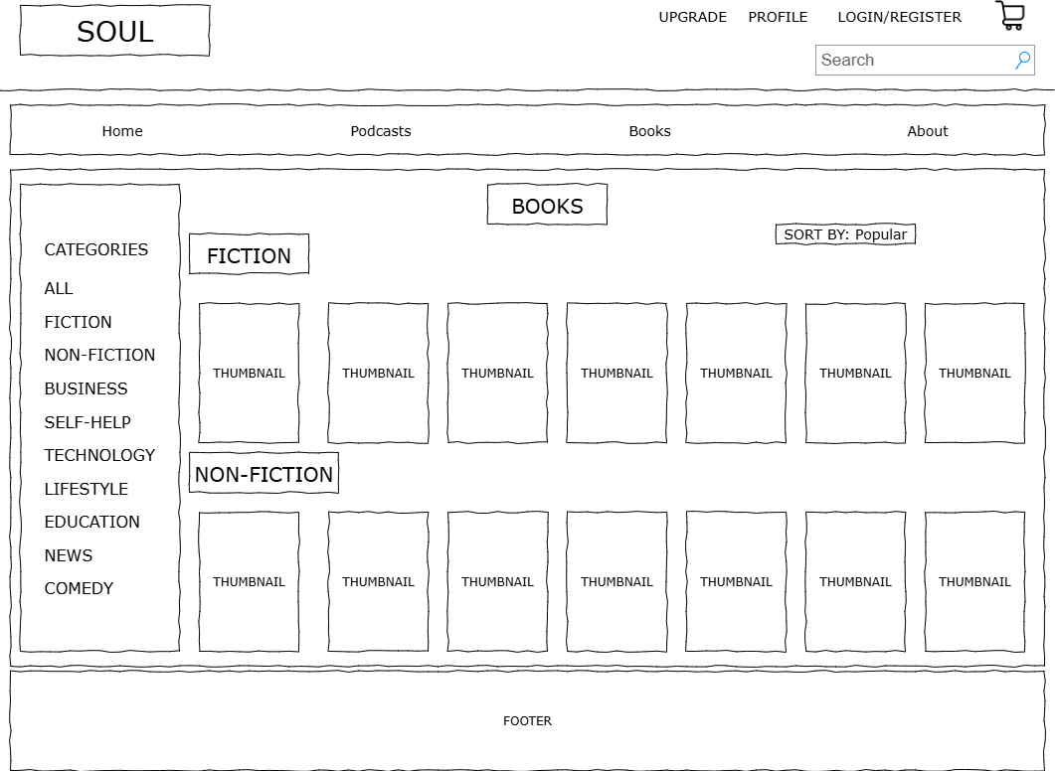

**Description**: Displays the full collection of books includes **Categories** (ALL, Fiction, Non-fiction, Business…), sorting options (Popular, Latest…), and a **grid/list** of book cards.Structured layout grouped by category.

**From**: Accessed from **Homepage (Books section)** or **Books menu tab**.

**To**: Navigate to Book Detail Page, other sections (Home, Podcasts, Profile, Order)

1. **Book Details**

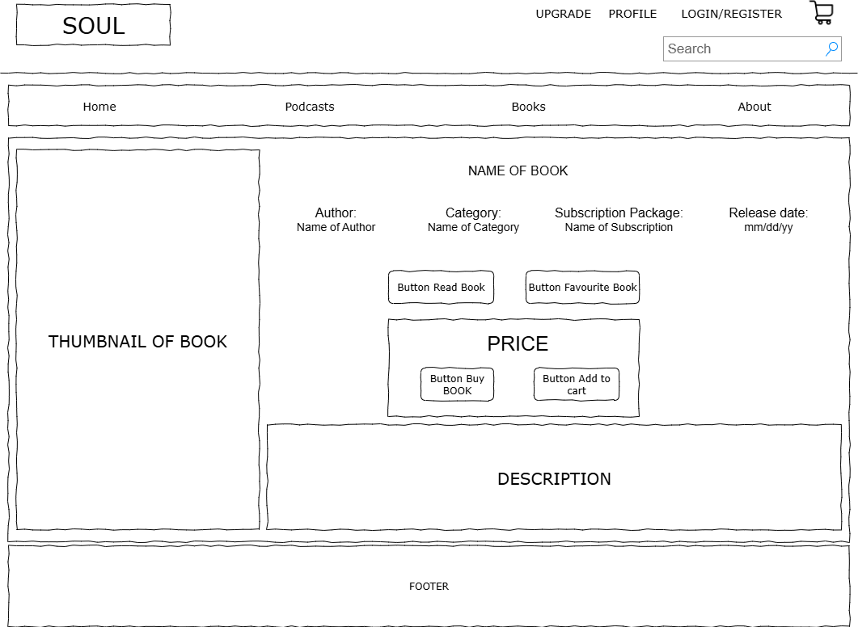

**Description**: Displays detailed information about a selected book, including its title, author, category, release date, and description. The layout includes a large book cover image, buttons for reading, buying, add to cart or adding the book to favorites, and a description section for extended content.

**From**: Accessed from the Books page (by selecting a specific book card) or links from Homepage, My Library, or search results.

**To**: Navigate to related book details, back to the Books listing, or other sections (Home, Podcasts, Profile, Order).

1. **Podcasts Page**

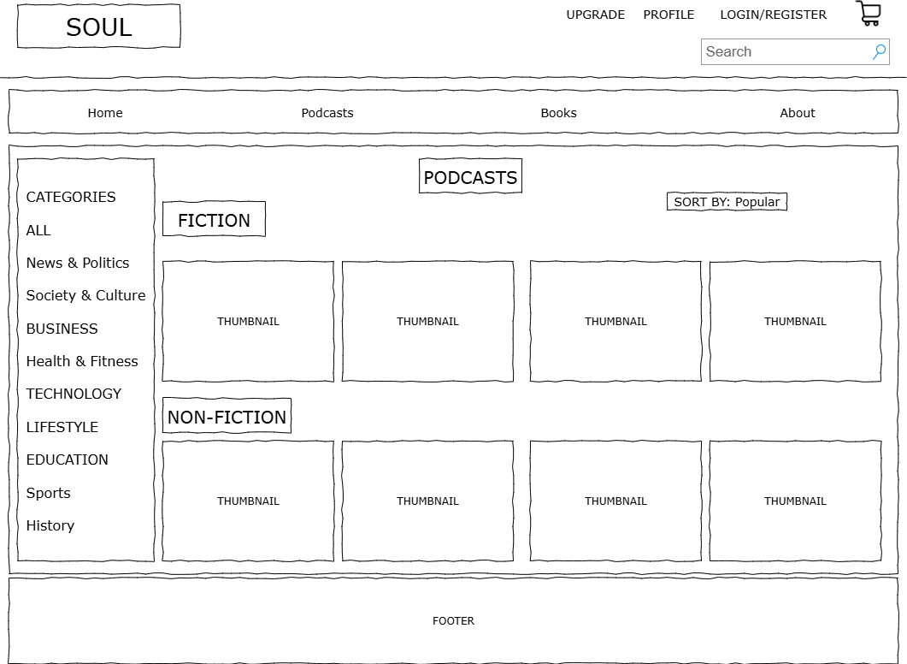

**Description**: Displays the full list of podcasts.Includes **Categories** (Business, Lifestyle, Comedy…), sorting options (Popular, Latest…), and a **grid/list** of podcast cards.Structured layout grouped by category.

**From**: Accessed from **Homepage (Podcasts section)** or **Podcasts menu tab**.

**To**: Navigate to Podcast Detail Page, other sections (Home, Books, Profile, Order).

1. **Podcast Details**

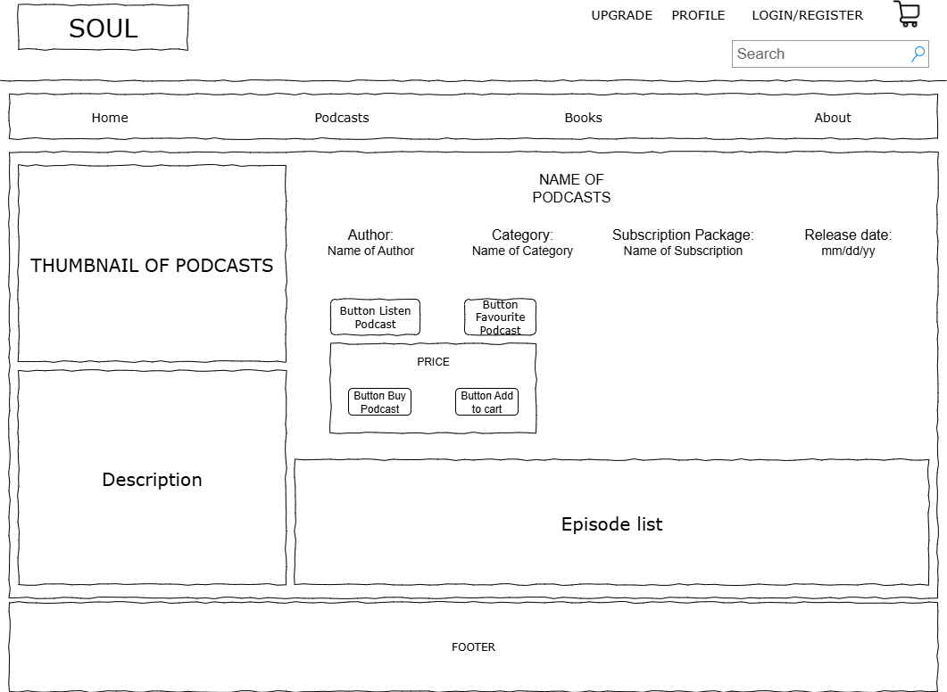

**Description**: Displays detailed information about a selected podcast, including the title, host/author, category, release date, and description. The layout highlights the podcast cover image, playback controls (play, pause, forward, rewind), and options such as adding to favorites or saving to playlist. Additional sections may include a list of episodes or related podcasts.

**From**: Accessed from the Podcasts page (by selecting a podcast card) or links from Homepage, My Library, or search results.

**To**: Navigate to related podcast details, back to the Podcasts listing, or other sections (Home, Books, Profile, Order).

1. **User Profile**

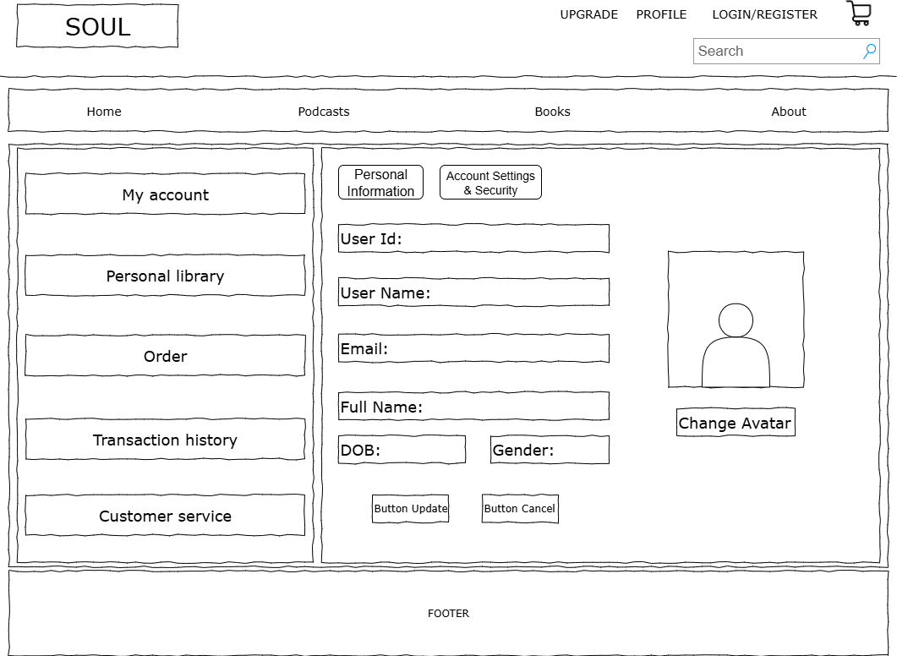

**Description**: User’s personal area includes User Info (avatar, edit profile), User Stats (Books saved, Podcasts listened), and My Library (saved Books & Podcasts).

**From**: Accessed from Home menu (top navigation).

**To**: Navigate to other sections (Home, Books, Podcasts, Order).

1. **User Profile Account Settings & Security**

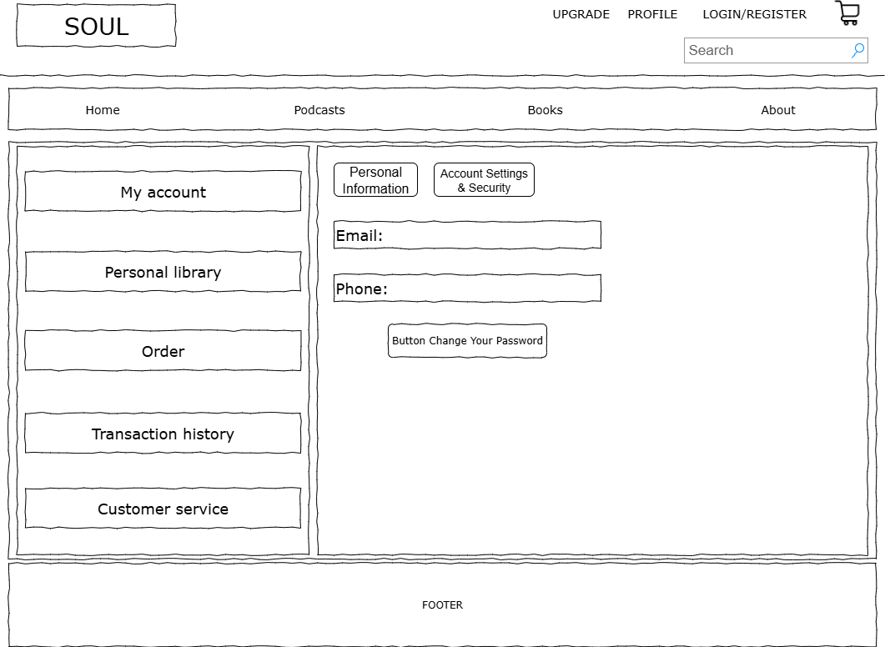

**Description:** Allows users to view their email and phone number  
**From:** From My Account  
**To:** Can lead to subpages such as Personal Information, Account Settings & Security, Change Password, Personal Library, Orders, Transaction History, and Customer Service.

1. **User Profile Account Change Password**

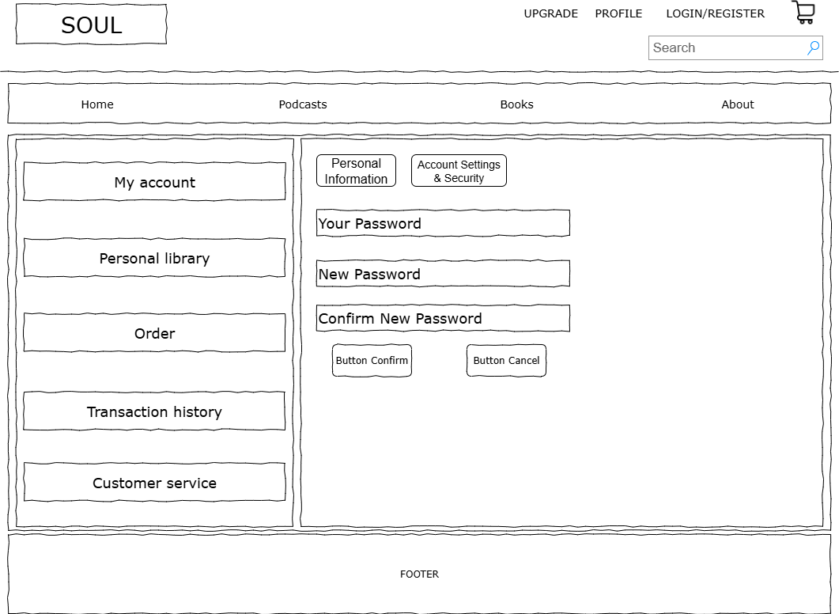

**Description:** Allows users to change their old password to a new password  
**From:** From the "Change Your Password" button  
**To:** Can lead to subpages such as Personal Information, Account Settings & Security, Personal Library, Orders, Transaction History, and Customer Service.

1. **User Profile Personal Library**

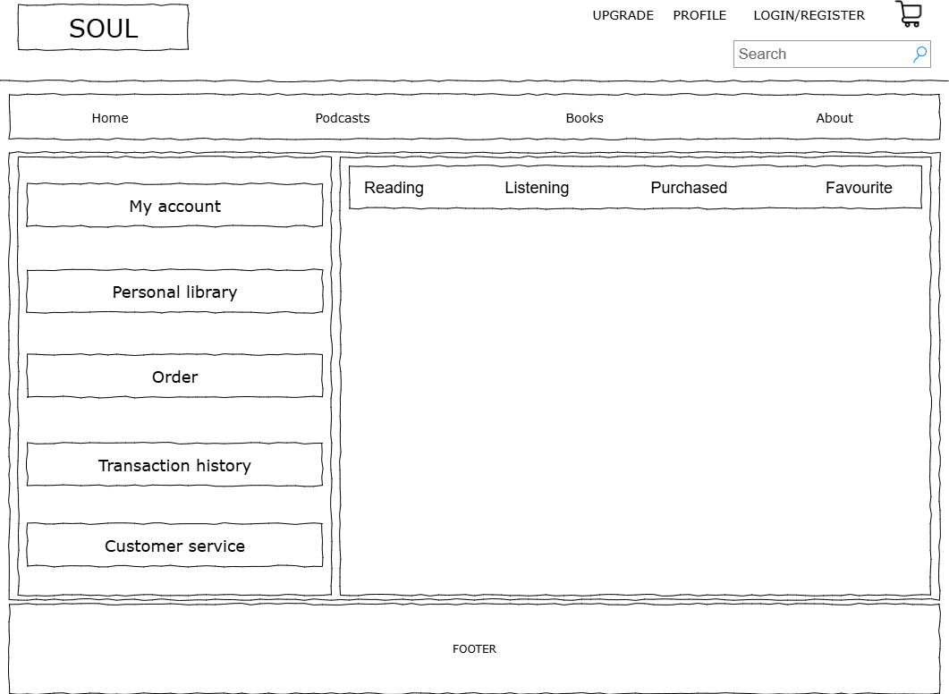

**Description:** Allows users to view their personal library, including books currently being read, podcasts currently being listened to, purchased items, and favorites.  
**From:** Can be accessed from My Account, Orders, Transaction History, or Customer Service  
**To:** Can lead to subpages such as My Account, Personal Library, Orders, Transaction History, and Customer Service.

1. **User Profile Order**

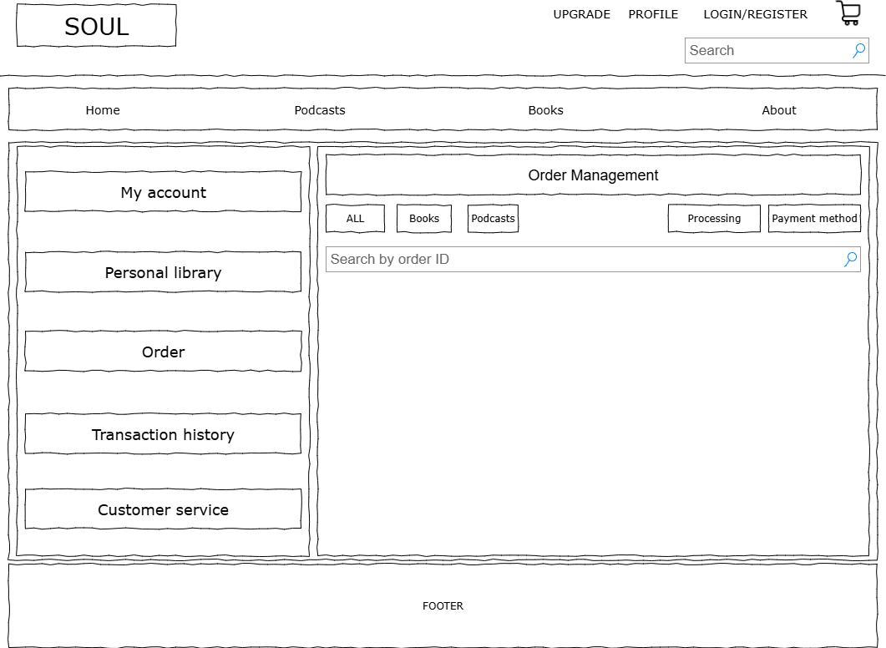

**Description:** Allows users to view the items they have ordered  
**From:** Can be accessed from My Account, Orders, Transaction History, or Customer Service  
**To:** Can lead to subpages such as My Account, Personal Library, Orders, Transaction History, and Customer Service.

1. **User Profile Transaction History**

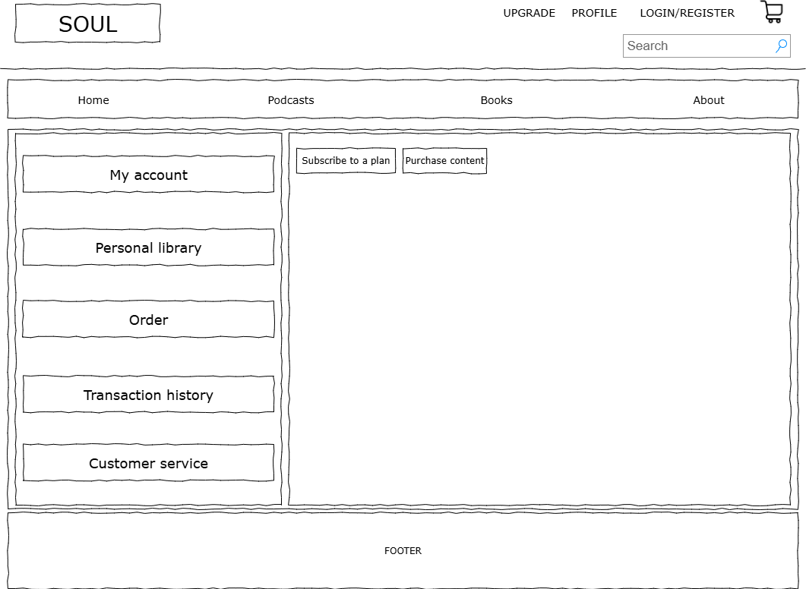

**Description:** Allows users to view purchased plans or digital content they have bought  
**From:** Can be accessed from My Account, Orders, Transaction History, or Customer Service  
**To:** Can lead to subpages such as My Account, Personal Library, Orders, Transaction History, and Customer Service.

1. **User Profile Customer Service**

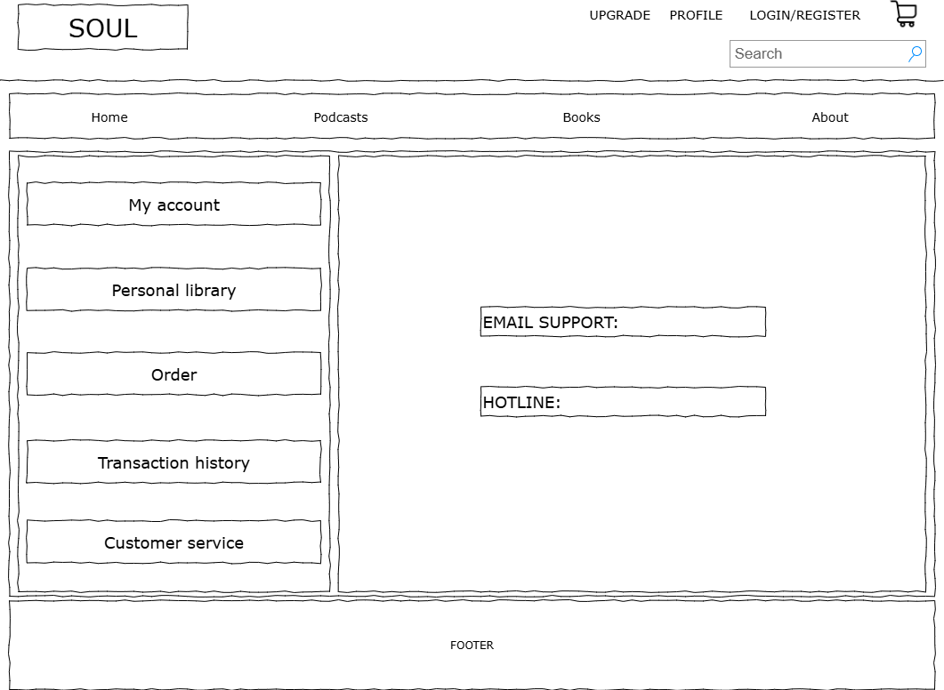

**Description:** Allows users to contact the website’s customer support  
**From:** Can be accessed from My Account, Orders, Transaction History, or Customer Service  
**To:** Can lead to subpages such as My Account, Personal Library, Orders, Transaction History, and Customer Service.

1. **Shopping Cart Page**

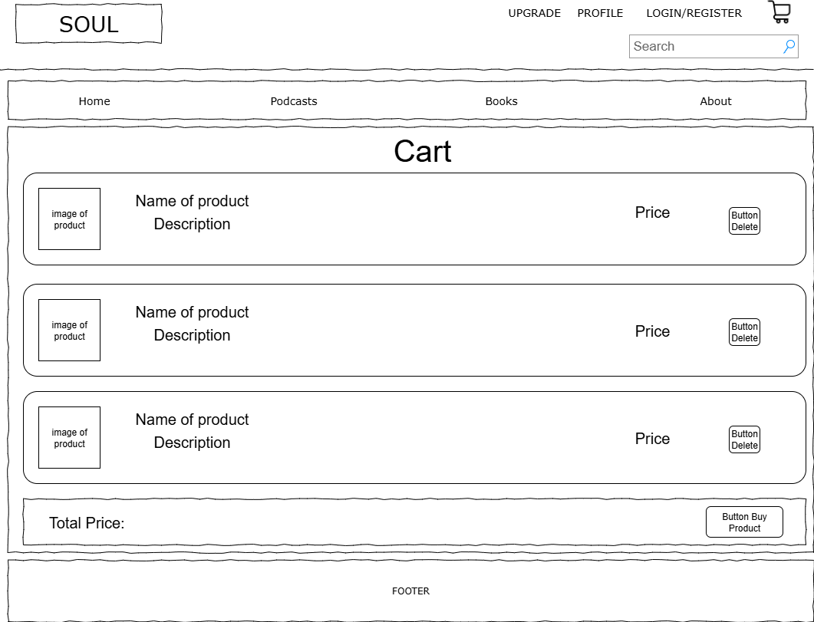

**Description:** Allows users to view the products added to the cart and either remove them or explore more items  
**From:** From the website header with the shopping cart icon  
**To:** Can lead to all website functions

1. **Upgrade Page**

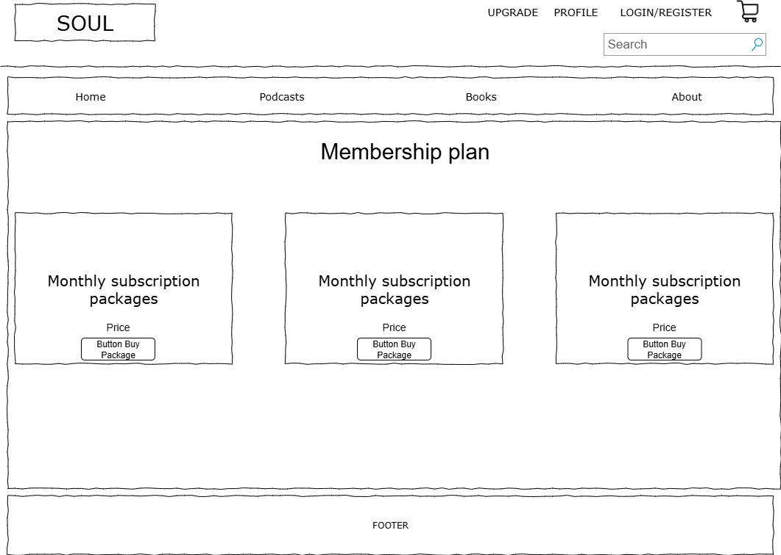

**Description:** Allows users to subscribe by selecting different plan types  
**From:** From the Upgrade function on the website header  
**To:** Can lead to homepage, podcasts, books, or profile

1. **Admin Dashboard Overview**

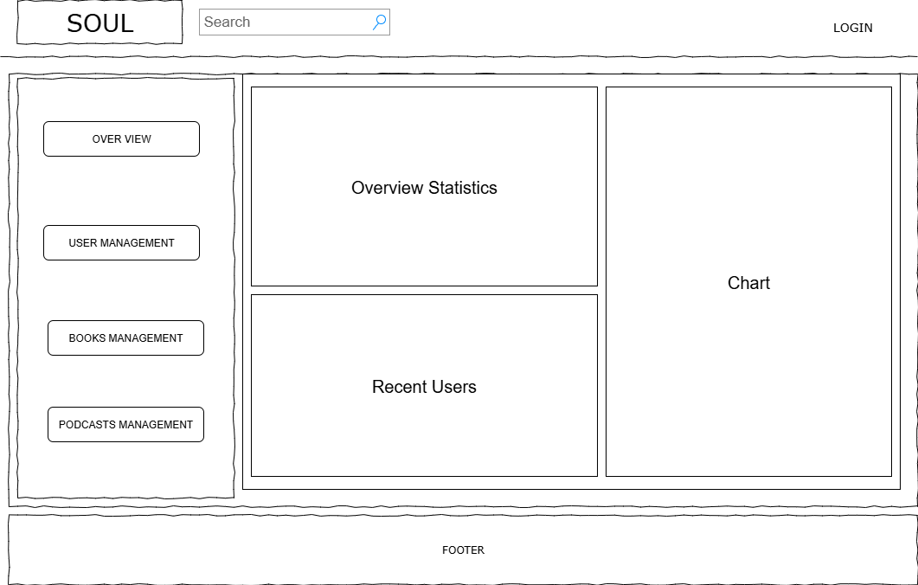

**Description:** On this page, users can view statistics, manage users, books, and podcasts, as well as see the list of current users.  
**From:** This is the main page, so when accessing the link it will display the Overview  
**To:** Navigate to Users Management, Books Management, and Podcasts Management

1. **User Management**

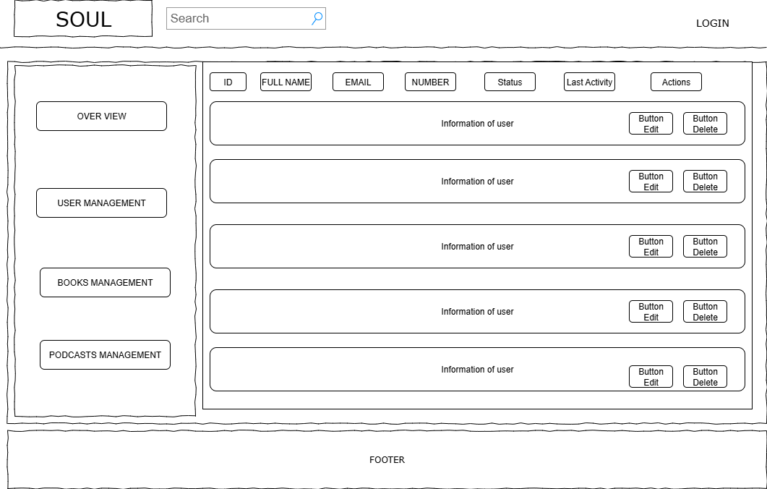

**Description:** Allows managing users with options to view, add, edit, and delete  
**From:** From Overview, Books Management, or Podcasts Management via the left navigation bar  
**To:** Navigate to Overview, Books Management, and Podcasts Management

1. **Books Management**

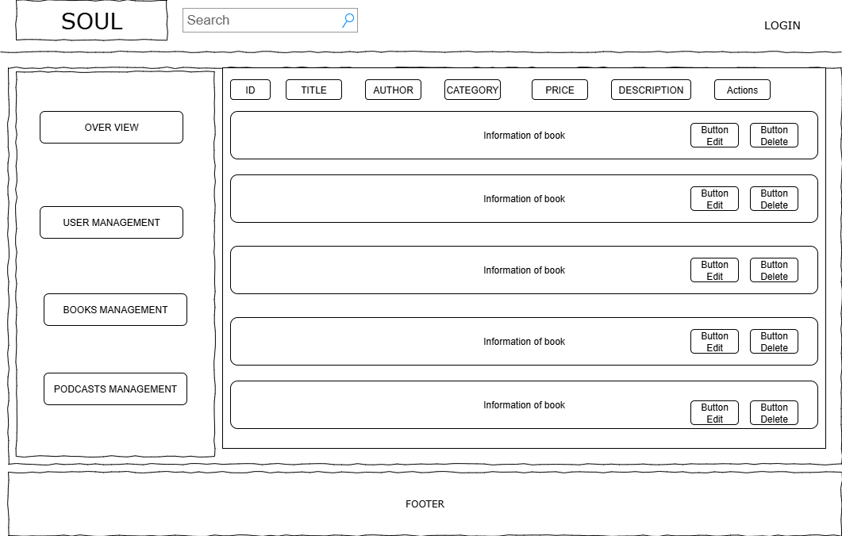

**Description**: Allows managing books with options to view, add, edit, and delete

**From**: From Overview, Users Management, or Podcasts Management via the left navigation bar

**To**: Navigate to Overview, Users Management, and Podcasts Management

1. **Podcasts Management**

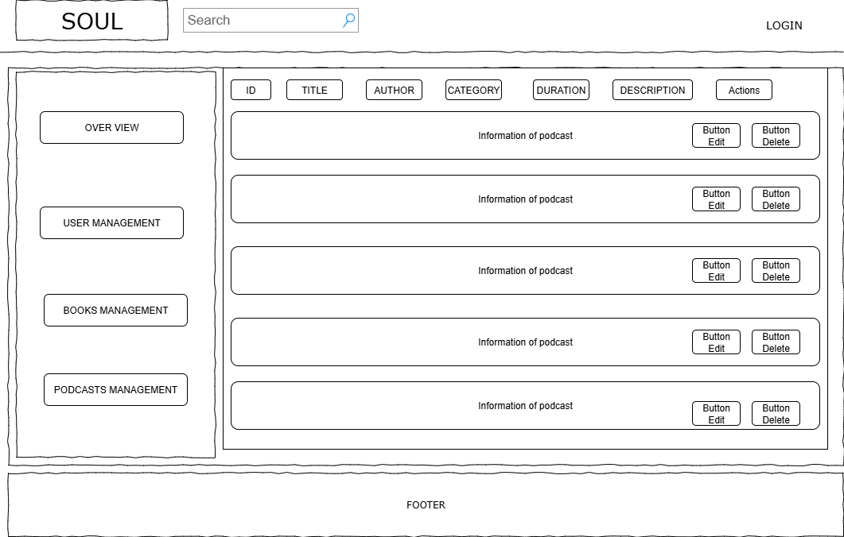

**Description**: Allows managing podcasts with options to view, add, edit, and delete

**From**: From Overview, Users Management, or Books Management via the left navigation bar

**To**: Navigate to Overview, Users Management, and Books Management

|  |
| --- |
| **Testing document** |

|  |  |  |
| --- | --- | --- |
| **Sr.No** | **Features Tested** | **Remarks** |
| 1 | Logo & Navigation bar (Home, Podcasts, Books, About) | PASS |
| 2 | Profile & Login/Register button | PASS |
| 3 | Search bar | PASS |
| 4 | Shopping cart icon | PASS |
| 5 | Book list hiển thị theo Category | PASS |
| 6 | Sort by (Popular, Newest…) | PASS |
| 7 | Book detail page (Name, Author, Category, Release Date) | PASS |
| 8 | Podcast list hiển thị theo Category | PASS |
| 9 | Podcast detail page (Name, Author, Category, Release Date) | PASS |
| 10 | My Orders page (All, Processing, Completed, Canceled) | PASS |
| 11 | Search by Order ID | PASS |
| 12 | Profile page (User Info, Edit Profile, My Library, Stats) | PASS |
| 13 |  |  |
| 14 |  |  |
| 15 |  |  |

|  |
| --- |
| **Final checklist** |

|  |  |  |
| --- | --- | --- |
| **Sr.No** | **Aspected Tested** | **Suggestion/**  **Remarks** |
| 1 | Are all the users able to view the images and links? | PASS |
| 2 | Have all the views, modules and controllers been properly integrated and is the site function as a single page application? | PASS |
| 3 | Are the GUI content devoid of spelling mistakes? | PASS |
| 4 | Is the application user-friendly? | PASS |
| 5 | Is the Website launching correctly in all popular browsers? | PASS |
| 6 | Are all the forms validated with proper criteria? | PASS |
| 7 | Do all text links lead to the appropriate website? | PASS |
| 8 | Do all image links lead to the appropriate website? | PASS |
| 9 | Are all the images and links clearly visible on the page? | PASS |
| 10 | Does the Web page work properly in all the tested browsers? | PASS |
| 11 | Does the Web page take too long to be loaded fully? | PASS |
| 12 | Is the navigation sequences correct through all the Web pages on the site? | PASS |
| 13 | Is the JavaScript code working as expected in all click events? | PASS |
|  |  |  |
|  |  |  |

|  |  |  |  |  |  |  |  |  |
| --- | --- | --- | --- | --- | --- | --- | --- | --- |
| **No** | **Member** | **Contents** | | **Table Name** | **Activity Plan** | **Date of Preparation of Activity Plan** | | |
| **Planed Start Date** | **Actual Start Date** | **Actual Days** | **Status** |
| 1 | **Trần Phúc Khang** | Admin | *User Managemet* | Users, user_subscriptions favourites | 20/08/2025 | 20/08/2025 | 30 | OK |
| 2 | 20/08/2025 | 20/08/2025 | 30 | OK |
| 3 | User | *Subscription Management, Favorites Management* | 20/08/2025 | 20/08/2025 | 30 | OK |
| 4 |  |  |  |  | 20/08/2025 | 20/08/2025 | 30 | OK |
|  | **Mai Thanh Đạt** | Admin | *Order Management* | orders, order_items, payments |  |  |  |  |
| 1 | User | *Order Management* | 20/08/2025 | 20/08/2025 | 30 | OK |
| 2 | 20/08/2025 | 20/08/2025 | 30 | OK |
| 3 | 20/08/2025 | 20/08/2025 | 30 | OK |
| 4 | Payment getway | *Payment Processing* | 20/08/2025 | 20/08/2025 | 30 | OK |
|  |  |  |  |  | 20/08/2025 | 20/08/2025 | 30 | OK |
| 1 | **Nguyễn Kim Minh** | Admin | *Product Management* | products, Product_files, continues |  |  |  |  |
| 2 | 20/08/2025 | 20/08/2025 | 30 | OK |
| 3 | User | *Add Order* | 20/08/2025 | 20/08/2025 | 30 | OK |
| 4 | *Personal Order Management* | 20/08/2025 | 20/08/2025 | 30 | OK |
|  |  |  |  |  |  |  |  |  |